|  |  |
| --- | --- |
| **Exp.no:**10 | **Design of scientific calculator** |
| **Date:**12-09-19 |

**Aim:**To design a calculator using event-driven programming paradigm of Java with Decimal and Scientific manipulations.

**Algorithm:**

Step 1: Declare a package calc.

Step 2: Declare the class MyCalculator that extends Frame and implements WindowListener and Action Listener.

Step 3: Add textfield, required buttons, panel, and static members.

Step 4: In the constructor, link WindowListener, ActionListener and Panel to the class and add buttons to the panel.

Step 5: Use ActionListener to perform the required actions.

**Class Diagram:**

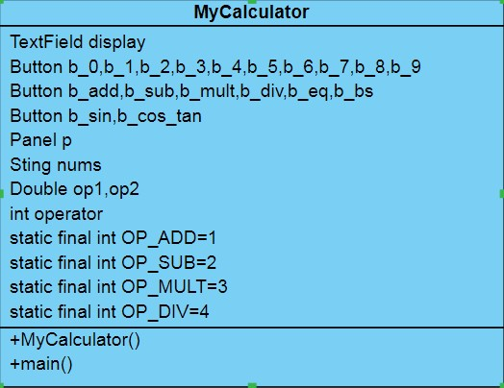

**Program:**

/***

* created by P.sumanth
* 212217105047
* Eee.b
* */

package calculator;

import java.awt.*; import java.awt.event.ActionEvent; import java.awt.event.ActionListener; import java.awt.event.WindowEvent; import java.awt.event.WindowListener;

public class MyCalculator extends Frame implements

WindowListener,ActionListener{

TextField display;

Button b_0,b_1,b_2,b_3,b_4,b_5,b_6,b_7,b_8,b_9;

Button b_add,b_sub,b_mul,b_div,b_eq,b_sin,b_cos,b_tan;

Panel p;

String nums; Double op1,op2; int operator; static final int OP_ADD=1; static final int OP_SUB=2; public MyCalculator()

{ this.addWindowListener(this); this.setLayout(new GridLayout(2,1)); nums="0";

display=new TextField("0"); display.setEditable(false); this.add(display);

p=new Panel();

p.setLayout(new GridLayout(3,2)); this.add(p);

b_0=new Button("0"); b_0.addActionListener(this); p.add(b_0);

b_1=new Button("1"); b_1.addActionListener(this); p.add(b_1);

b_2=new Button("2"); b_2.addActionListener(this); p.add(b_2);

b_3=new Button("3"); b_3.addActionListener(this); p.add(b_3);

b_4=new Button("4"); b_4.addActionListener(this); p.add(b_4);

b_5=new Button("5"); b_5.addActionListener(this); p.add(b_5);

b_6=new Button("6"); b_6.addActionListener(this); p.add(b_6);

b_7=new Button("7"); b_7.addActionListener(this); p.add(b_7);

b_8=new Button("8"); b_8.addActionListener(this); p.add(b_8);

b_9=new Button("9"); b_9.addActionListener(this); p.add(b_9);

b_add=new Button("+"); b_add.addActionListener(this); p.add(b_add);

b_sub=new Button("-"); b_sub.addActionListener(this); p.add(b_sub);

b_eq=new Button("="); b_eq.addActionListener(this); p.add(b_eq);

b_div=new Button("/"); b_div.addActionListener(this); p.add(b_div);

b_mul=new Button("*"); b_mul.addActionListener(this); p.add(b_mul);

b_sin=new Button("sin"); b_sin.addActionListener(this); p.add(b_sin);

b_cos=new Button("cos"); b_cos.addActionListener(this); p.add(b_cos);

b_tan=new Button("tan"); b_tan.addActionListener(this); p.add(b_tan); }

public static void main(String[] args) { MyCalculator mc;

mc=new MyCalculator(); mc.setSize(300,250); mc.setTitle("calculator"); mc.setVisible(true);

}

@Override

public void windowOpened(WindowEvent e) { // TODO Auto-generated method stub

}

@Override

public void windowClosing(WindowEvent e) { System.exit(0);

}

@Override

public void windowClosed(WindowEvent e) { // TODO Auto-generated method stub

}

@Override

public void windowIconified(WindowEvent e) { // TODO Auto-generated method stub

}

@Override

public void windowDeiconified(WindowEvent e) { // TODO Auto-generated method stub

}

@Override

public void windowActivated(WindowEvent e) { // TODO Auto-generated method stub

}

@Override

public void windowDeactivated(WindowEvent e) { // TODO Auto-generated method stubb

}

@Override

public void actionPerformed(ActionEvent e) { // TODO Auto-generated method stub if(e.getSource()==b_0)

{ nums=nums+"0";

display.setText(nums);

}else if(e.getSource()==b_1)

{ nums=nums+"1";

display.setText(nums); }else if(e.getSource()==b_2)

{ nums=nums+"2";

display.setText(nums); }else if(e.getSource()==b_3)

{ nums=nums+"3";

display.setText(nums); }else if(e.getSource()==b_4)

{ nums=nums+"4";

display.setText(nums); }else if(e.getSource()==b_5)

{ nums=nums+"5";

display.setText(nums); }else if(e.getSource()==b_6)

{ nums=nums+"6";

display.setText(nums); }else if(e.getSource()==b_7)

{ nums=nums+"7";

display.setText(nums); }else if(e.getSource()==b_8)

{ nums=nums+"8";

display.setText(nums); }else if(e.getSource()==b_9)

{ nums=nums+"9";

display.setText(nums);

}else if(e.getSource()==b_add)

{ op1=Double.parseDouble(nums); nums="0"; display.setText(nums); operator=OP_ADD;

}else if(e.getSource()==b_eq)

{ switch(operator)

{ case OP_ADD:

op2=Double.parseDouble(nums); nums=""+(op1+op2); display.setText(nums); break;

}

}else if(e.getSource()==b_sub)

{ op1=Double.parseDouble(nums); nums="0"; display.setText(nums); operator=OP_SUB;

}else if(e.getSource()==b_eq)

{ switch(operator) { case OP_SUB: op2=Double.parseDouble(nums); nums=""+(op1-op2); display.setText(nums); break;

}

}else if(e.getSource()==b_sin)

{ op1=Double.parseDouble(nums); nums=""+Math.sin(op1*Math.PI/180); display.setText(nums);

}else if(e.getSource()==b_cos)

{ op1=Double.parseDouble(nums); nums=""+Math.cos(op1*Math.PI/180); display.setText(nums);

}else if(e.getSource()==b_tan)

{ op1=Double.parseDouble(nums); nums=""+Math.tan(op1*Math.PI/180); display.setText(nums);

}

}

}

Output:

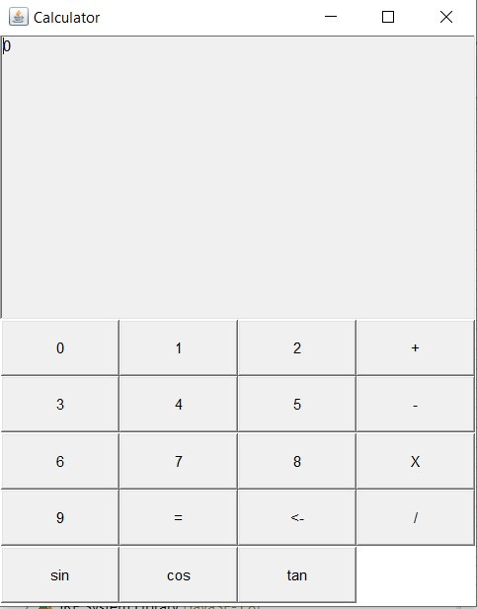

**Result:**

Thus a java console application that uses event-driven programming paradigm of Java to design a calculator with decimal and scientific manipulations is verified.